**CA 3: Experiential Learning**

**Group Members:**

|  |  |  |  |
| --- | --- | --- | --- |
| Sr. No. | PRN | Name of Student | Mail id |
| 1. | 22070122087 | Jay Trivedi | jay.trivedi.btech2022@sitpune.edu.in |
| 2. | 22070122102 | Krish Panchal | krish.panchal.btech2022@sitpune.edu.in |
| 3. | 22070122154 | Pranay Vasoya | pranay.vasoya.btech2022@sitpune.edu.in |

**Problem Statement:**

Build a C++ program using class inheritance and polymorphism for Trading System where following operations are performed:

1.Get account information

2.Deposit Money

3. Withdraw Money

4. Display Transactions

5.Buy Crypto coins

6.Sell Crypto coins

**Explanation:**

#### 1. Get Account Information:

In this operation, we will Just print the information about the user account. i.e., all the variables we have to observe are profit-loss, currencies, amount, etc.

#### 2. Deposit Money:

In deposit, we can deposit money in our account.

#### 3. Withdraw Money:

In withdrawal, we can withdraw the money we have in our account.

4. Display Transactions:

All the transactions taking place i.e., deposit and withdrawal of money will be displayed, also there is an option of clearing all the transaction by pressing Y, or not clearing any transaction by pressing N.

#### 5. Buy Cryptocurrencies:

We will buy crypto using this operation. We can buy either Bitcoin or Dogecoin depending on our needs.

#### 6. Sell Cryptocurrencies:

We will sell crypto and add the amount we get after selling to our account.

**Class Diagram:**

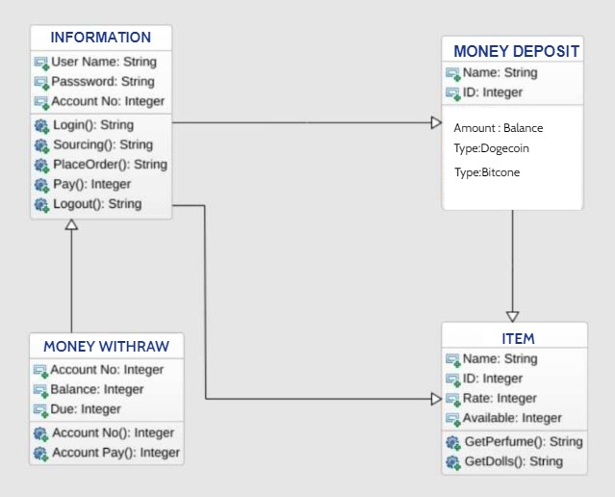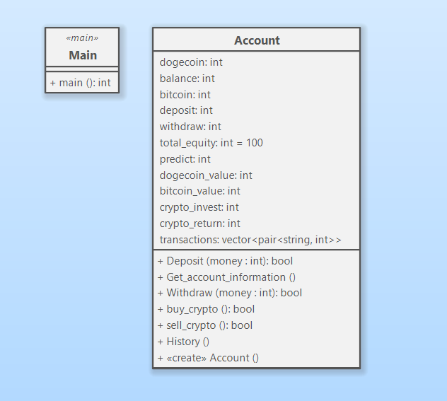

**Code snippets:**

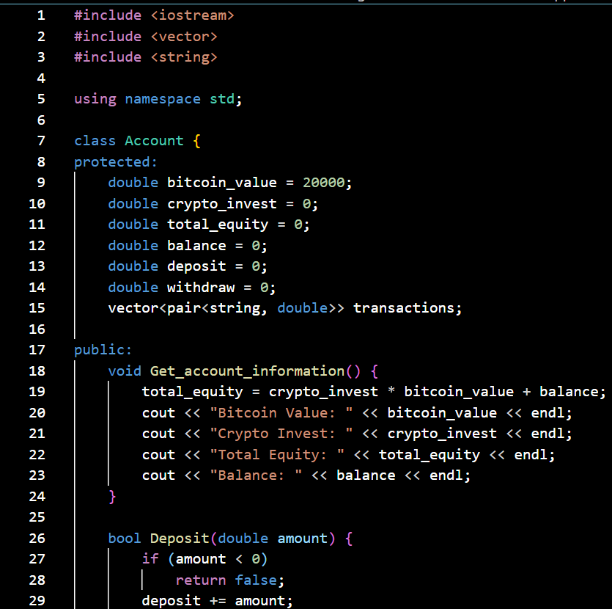

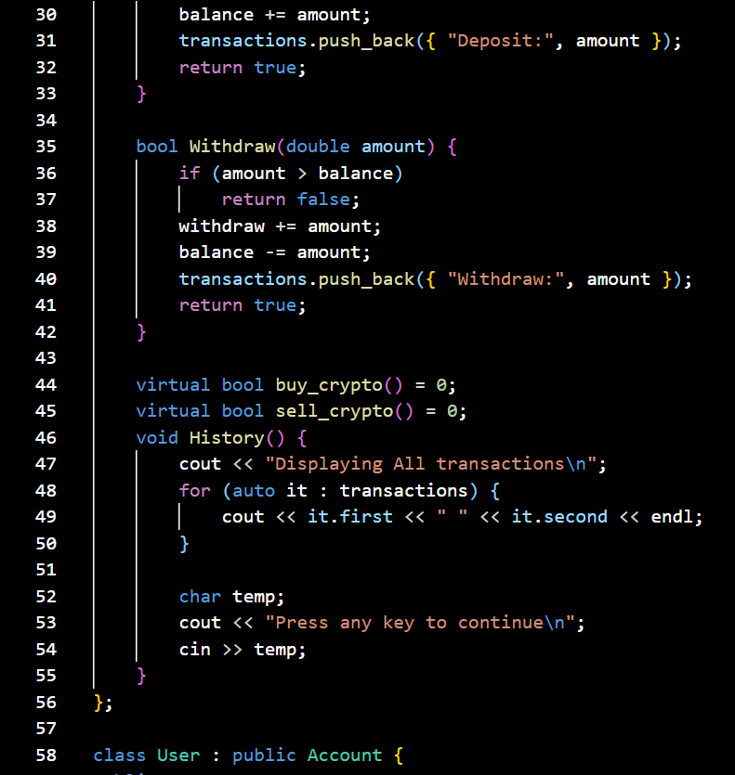

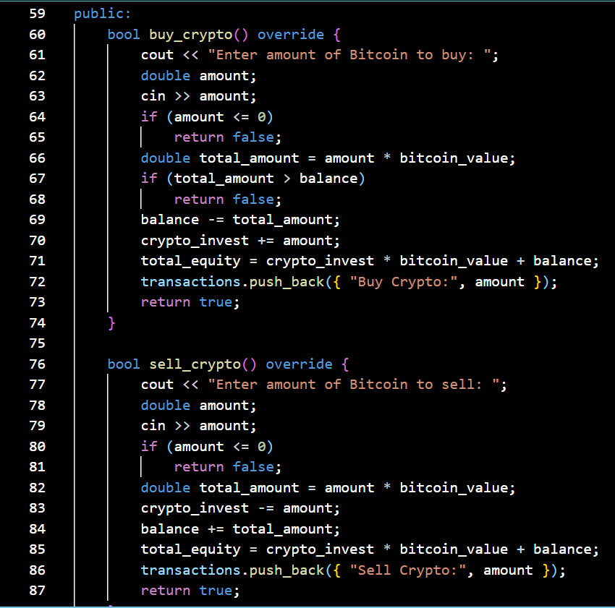

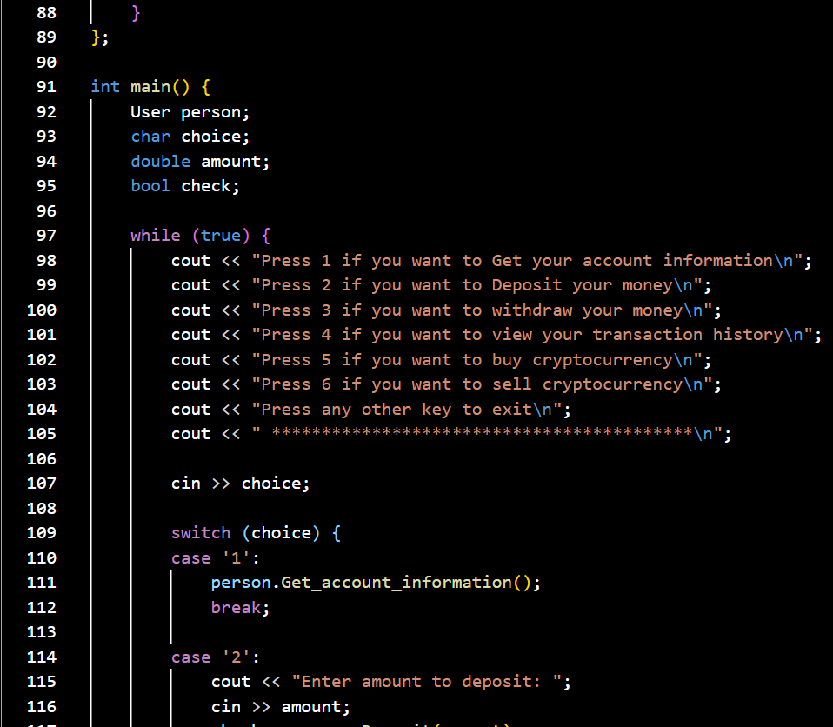

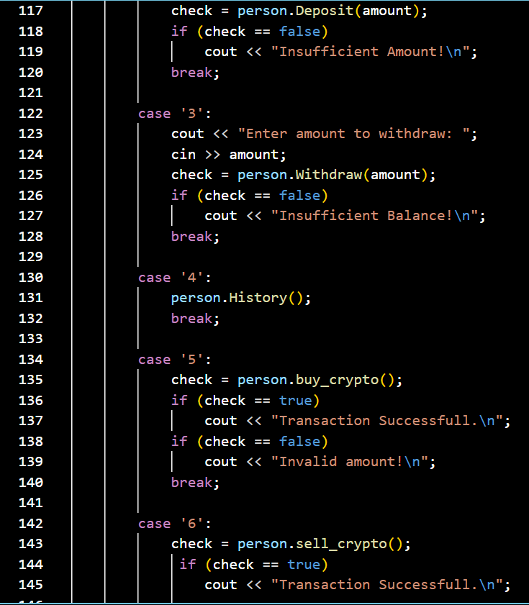

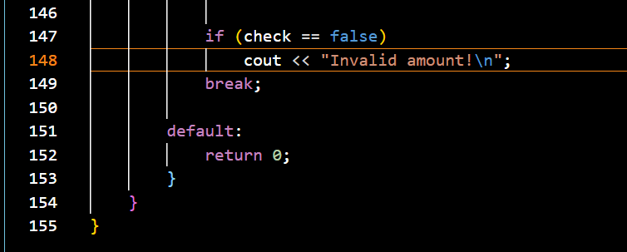

**Input/Output:**

**Deposit the money, Withdraw the money, Purchase of Bitcoin:**

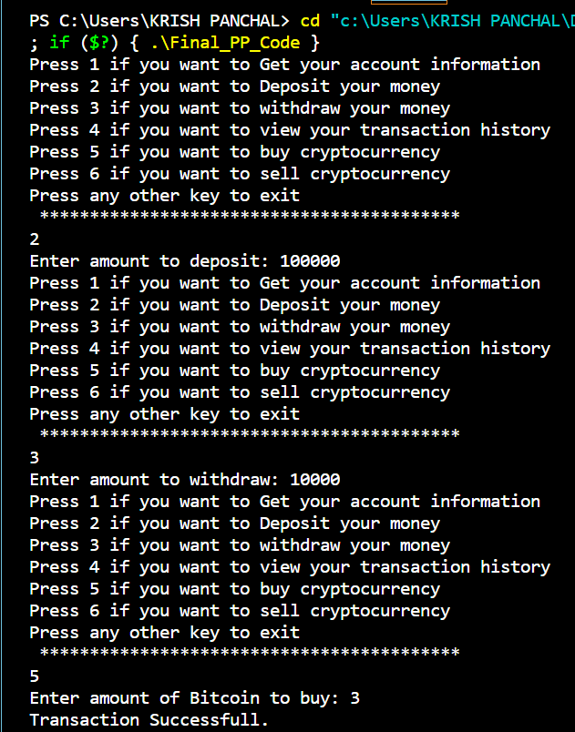

**Selling of Bitcoin, Get your account information:**

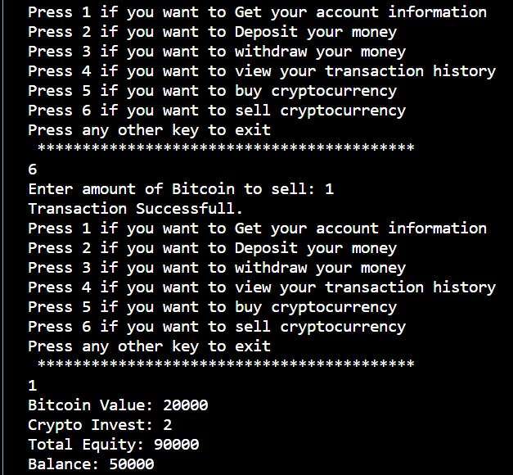

**Displaying Transactions:**

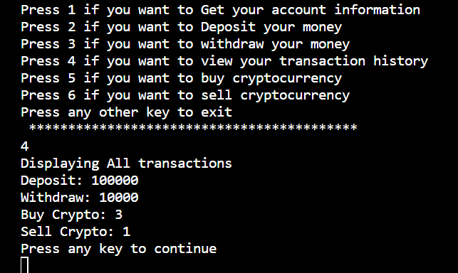

**GitHub repository link:**

|  |  |
| --- | --- |
| Jay Trivedi | <https://github.com/Jayu1214/Programming-Paradigms-Project-> |
| Krish Panchal | <https://github.com/KrishPanchal17/PP-Trading-System.git> |
| Pranay Vasoya | <https://github.com/PranayVasoya/PP-Trading-System.git> |